Advanced programming assignment 2

# **The ERD class diagram**

# **&**

# **The use case diagram**

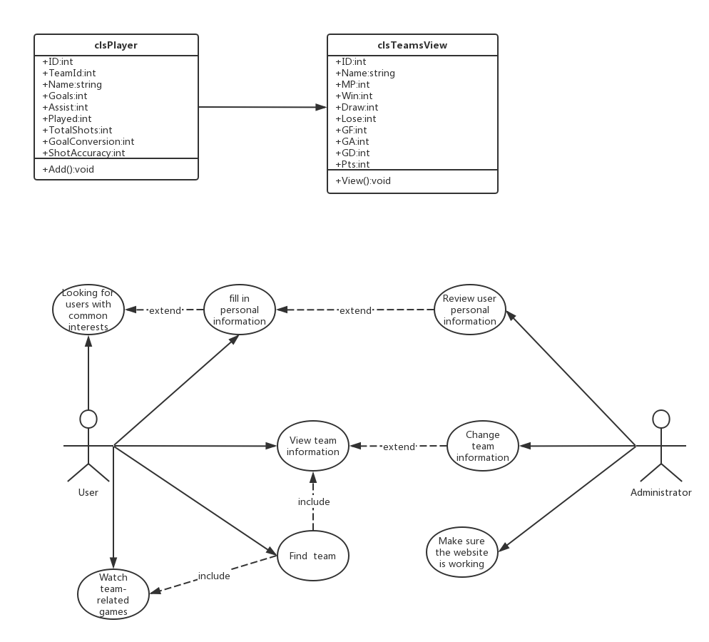

The Main page

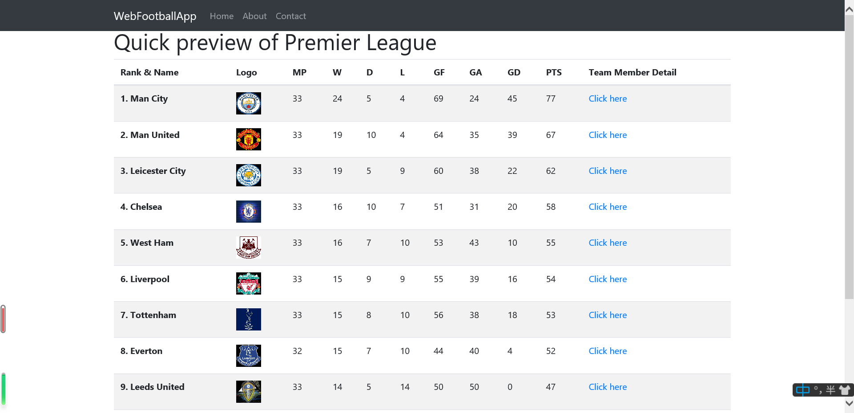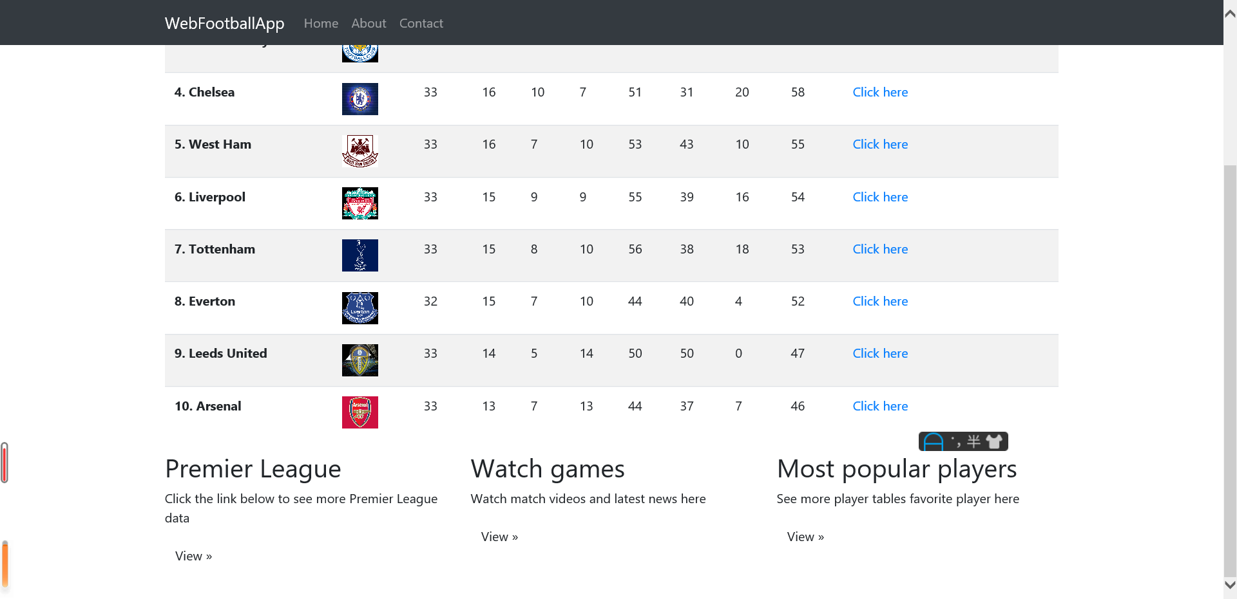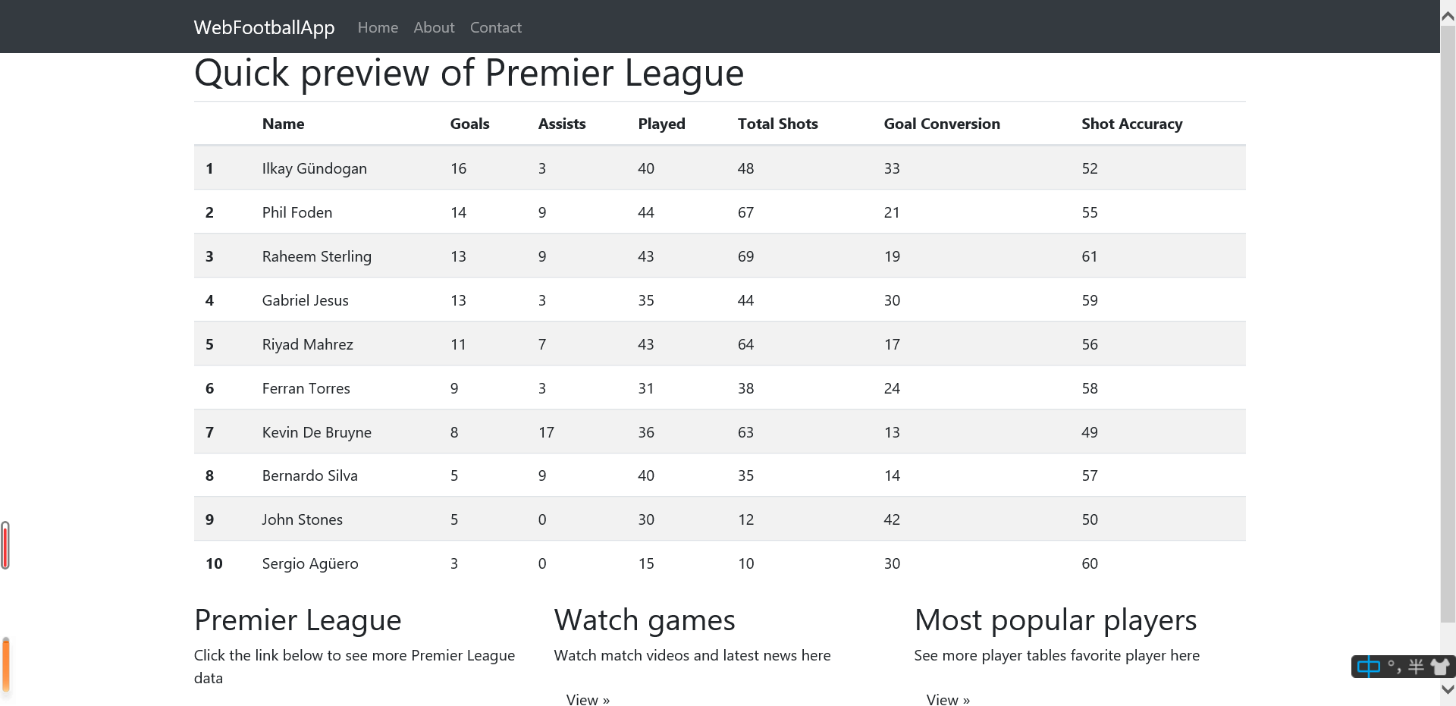

In addition, if the user clicks on the three "View" below, the link will take the user to the corresponding BBC football page, where the scores of the teams that have completed the Premier League game and the game play will be displayed video.

If the user is interested in a certain team, they can click "click here", then the user can see the information of the ten players of the team and their personal information in the Premier League

On the homepage, users can see various information about the top ten in the Premier League

**vision for the system**

1. The purpose of this website is to allow fans who want to know the Premier League to learn more intuitively and conveniently the information they want to know about the Premier League games, such as the scores between the teams, the wins and losses, and the performance of their favorite players.
2. This website is mainly aimed at young men who like football and are interested in the Premier League. These people want to intuitively feel the strengths and weaknesses of the teams, so they can intuitively show them the teams, players, teams and balls. The data between the teams interest them even more. Therefore, this website mainly collects and visually displays these relevant data.

**Difficulties encountered log**

|  |  |  |  |
| --- | --- | --- | --- |
| Difficult | Date | How to deal it | Deal time |
| **We wanted to delete something from the original code, but when we tried to merge to github, it was shown that it could not be merged.** | **4.26** | **After confirming that we did not know how to solve it, we sent an email to the teacher to know how to solve this problem.** | **4.27** |
| **Today we held a group meeting in person and discussed and made some progress, but I don’t know why. We still failed to upload the code many times, probably because of server problems.** | **4.27** | **We integrated the things discussed and saved them on our computer and successfully merged them into github afterwards.** | **4.28** |
| **Today we are studying how to arrange the data to display on the web page, but we don’t know why one has a bug that prevents us from successfully completing the work.** | **4.28** | **We finally found out that the object was not created, which wasted a lot of our time.** | **5.5** |